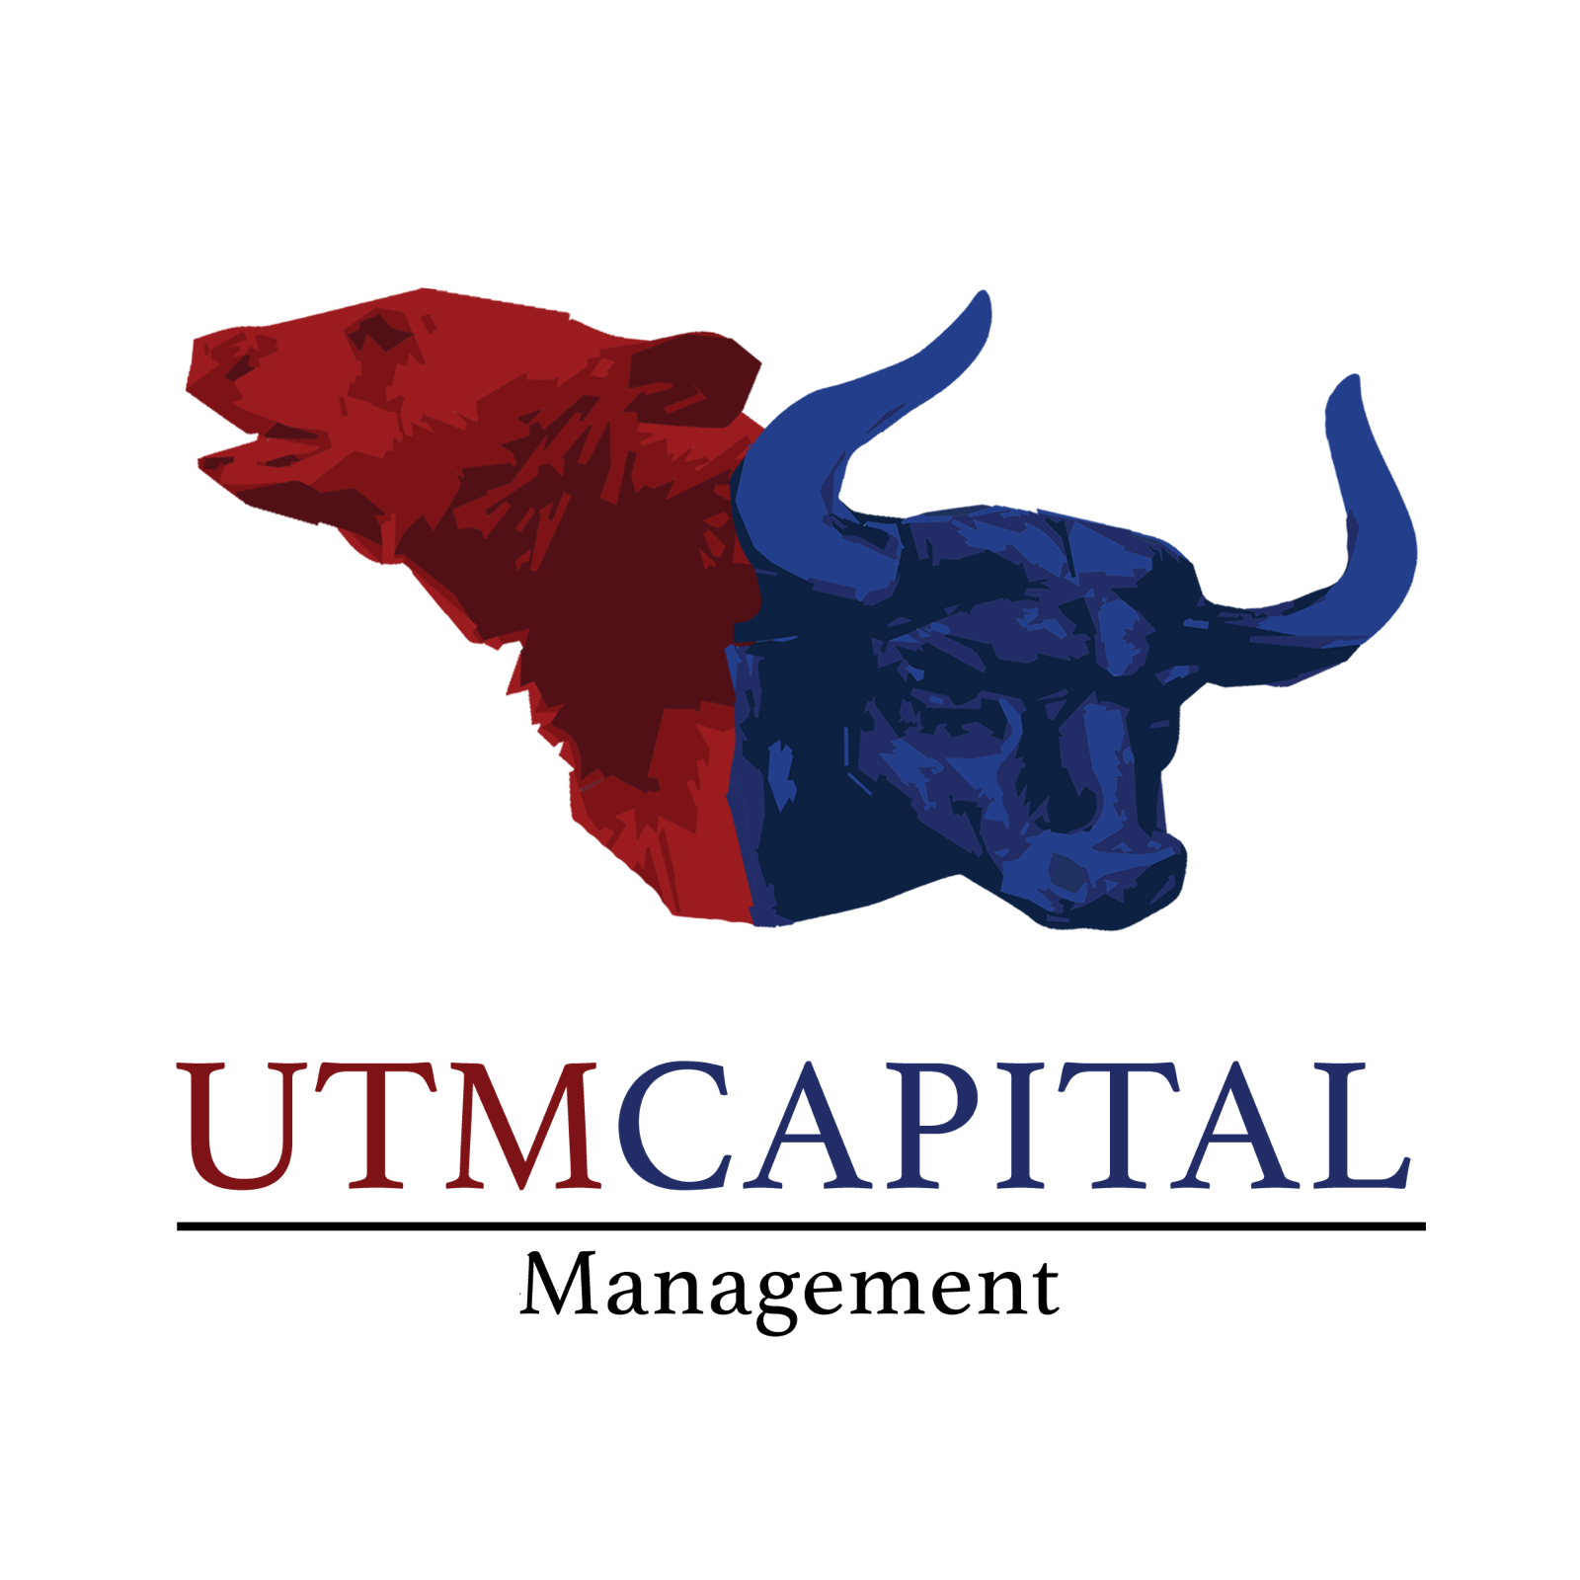

WACC & CAPM Guide
By: Laith Sabunchi
UTMCM President – 2022/2023

Introduction to WACC

WACC stands for the Weighted Average Cost of Capital. ‘Weighted Average’ implies some mathematics needed to gain proportions, whereases ‘Cost of Capital’ implies an attempt to identify the varying costs of capital for a given business. Sources of capital for a business are debt and equity, the WACC helps us in weighing debt and equity costs and thus represents the minimum rate of return in which a company produces value for investors.
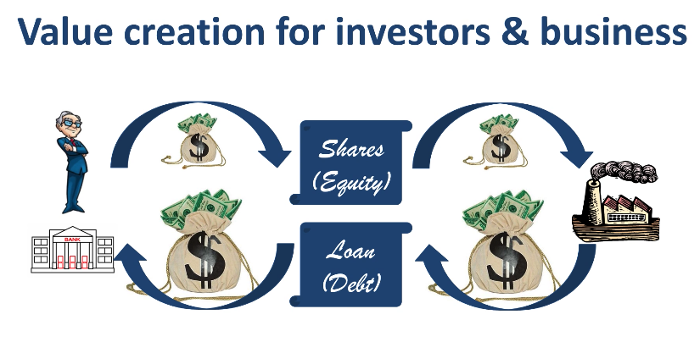

WACC is often taking as the discount rate when attempting to assess a company through the lens of a Discounted Cash Flow (DCF) analysis. For a company to operate and generate cash flows, both today and in the future, it has / will have to raise capital in the form of debt and equity securities. Theoretically, the market rate of such securities represents the risk associated with the company’s operations and potential returns. The blended rate of all these securities is considered the WACC, and thus is used as the appropriate measure to discount back cash flows. It would not be useful to use other metrics, such as US treasuries, to discount a company’s cash flows as these rates don’t specifically represent the company’s risk profile.

The formula for WACC is shown below:

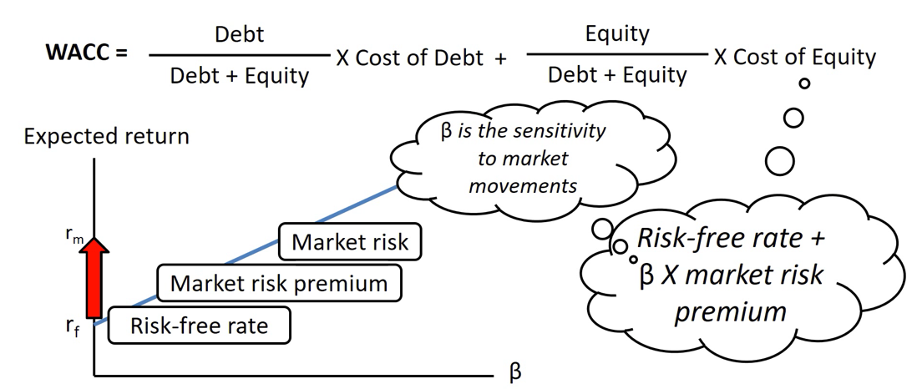

Introduction to CAPM

CAPM stands for the Capital Asset Pricing Model, a model that helps describe the relationship between the expected return and risk of investing in a given security. The model is an avenue investor can use to help calculate the Cost of Equity for a business, a key component of the WACC calculation.

CAPM = Cost of Equity = Risk-free rate + Beta * Market Risk Premium

Components:
- Risk free rate is often inputted as the safest investment one can make in a given market environment. Usually, it is the yield of 10-year US government bonds.
- Beta measures a stocks volatility relative to the general market. For example, if a company has a Beta of 1.5, the security has 150% of the volatility relative to the market average.
- Market Risk Premium refers to the difference between the expected return of the overall market minus the risk-free rate. Usually, the market returns refer to the average return of the S&P500 over an average number of years.

Steps to Calculating WACC

With the formula laid out we can now look at how to calculate the WACC and what pieces of information to draw upon.

For the debt side, once can calculate WACC by attaining:

- Cost of Equity
- Weight of equity
- Cost of equity
- Weight of debt
- Interest cost
- Tax rate

Note: Interest cost and tax rate serve as costs to debt.

This Guide will show two example calculations for WACC for two different companies in two different periods of time.


Detailed Example: Southwest Airlines (LUV) 2013
Note: All numbers reported in millions USD
Debt Calculations

To begin with, we must find all relevant costs contributed from Debt. We will first look at the income statement. With costs of debt, there are three specific pieces of information we need to gather:

- Interest paid over the course of the year
- Income made before taxes (taxable income)
- Tax amount paid

These can all be found at the bottom-half of the income statement. We note the following (all numbers in millions):

Interest expense – $147
Income before tax – $685
Income tax expense (Provision for income taxes) – $264

Next, the balance sheet.

We need to find the balances of debt for the current and preceding year, this will help us in figuring out the % of interest the company is likely to pay. We take the average balances of debt.

Long term debt is split into two components:
- long-term debt
- portion of long-term debt that is owed in the short term (listed as a current liability)

We can see from Southwest Airlines’ consolidated balance sheet there are listed debt amounts both as a general liability, and a current liability. We add them up to get the following:

2012: $2,883 + $271 = $3,154
2011: $3,107 + $644 = $3,751

At the beginning of the year, we had 3,751 in debt and towards the end of the year we had 3,154 so we paid some debt off, our interest rate considers the average of these two numbers to help us better gauge the interest raid Southwest Airlines pays for their debt financing. Average debt level: $3,400

Now, to calculate cost of interest over this period of time, we divide our interest paid by the average debt level:

147 / 3,400 = 4.26%

We figured out that Southwest Airlines has an average interest rate of 4.26% on the money they borrow.

To find after-tax cost of debt however, we need to find our tax rate. (How much income tax as a % does Southwest Airlines pay as its taxable income).

This is simply our income before tax / income tax expense
685 / 264
= 39% implied tax rate.

Equity Calculations

The next set of calculations involve us find the CAPM for Southwest Airlines, the required rate of return our owner’s demand, based on risk of the firm and rate of return on risk-free assets.

In this example, we will take the Risk-free rate of 10YR US Government treasuries for 2013, measured at 1.75%

Expected market return is usually listed at 7.5% and represents the average return of S&P 500 over a multi-year period.

Southwest Airlines Share Price: $13.34
Shares Outstanding: 728,100 (in thousands)
Market Value of Equity (or Market Cap) = 9.7 Billion, re-written as 9,700

Southwest Airlines Beta: .90 (taken from external internet source). This tells us that for Every $1 increase in the market, southwest increases by .90 cents.

Cost of equity = risk free rate + Beta * Market risk premium

= 1.75% + (0.9 * (7.5% - 1.75%))
= 6.93%, which is less than the market return, which we expect because beta is less than 1.

Weight Calculations

Calculate weight of equity, which represents percentage of externally supplied funds that have been supplied shareholders.

Weight of equity = (dollar value of equity / dollar value of equity + dollar value of debt)

= 9,700 / 9,700 + 3,154
= 75%

(note: for debt level we used the latest amount of 3,154. There is no need to use average debt level for this part of the calculation).

Calculate weight of debt, what percentage of externally supplied shareholders have been supplied by lenders.

Weight of Debt = dollar value debt / dollar value of equity + dollar value of debt

= 3,154 / 3,154 + 9,700
= 25%

They both add up to 100%

This tells us that 25% of funds come from debt holders and 75% of funds come from shareholders.

Final WACC Calculation:

Weight of equity - 75%

Cost of equity - 6.93%

Weight of debt - 25%

Interest Cost - 4.26%

Tax Rate - 39%

WACC = 75% * 6.93% + 25% * 4.26% * (1 - 39%)
WACC = 5.85%


Quick Example 1: Adobe (ADBE) 2021

Debt Calculations

Interest expense / Interest Paid – $113,000,000

Income before tax (Income before Income Taxes) – $5,705,000,000

Income tax expense (Provision for income taxes) – $883,000,000

Long term debt:

2021: 4,123,000,000
2020: 4,117,000,000
(No long-term debt portions involved in current liabilities).

Average Debt Level:
4,120,000,000

Implied Interest rate for debt
113,000,000 / 4,120,000,000 = 2.75%

Implied Tax rate
883,000,000 / 5,705,000,000 = 15.48%

Equity Calculations

Risk free rate = 4.20%
Expected market return = 7.5%
Market Cap = 138,000,000,000
Beta = 1.2

Cost of Equity = 4.20% + (1.2(7.5%-4.20%)
= 8.16%

Weight Calculations

Weight of equity
= 138,000,000,000 / 138,000,000,000 + 4,123,000,000
= 97.1%

Weight of Debt
= 4,123,000,000 / 138,000,000,000 + 4,123,000,000
= 2.9%

Final WACC Calculation:

Weight of equity = 97.1%

Cost of equity = 8.16%

Weight of debt = 2.9%

Interest cost = 2.75%

Tax rate = 15.48%

WACC = 97.1 * 8.16 + 2.9*2.75*(1 – 0.1548)
= 8%

